Monish Nene

ESD LAB1 Report

**Things Learnt in Lab1**

Wire Wrapping

SPLD

ALE Frequency is 1/6th of Crystal Frequency when no code is loaded in 8051.

**Toughest Thing to do**

Unsoldering a wrong component for replacing it with correct component.

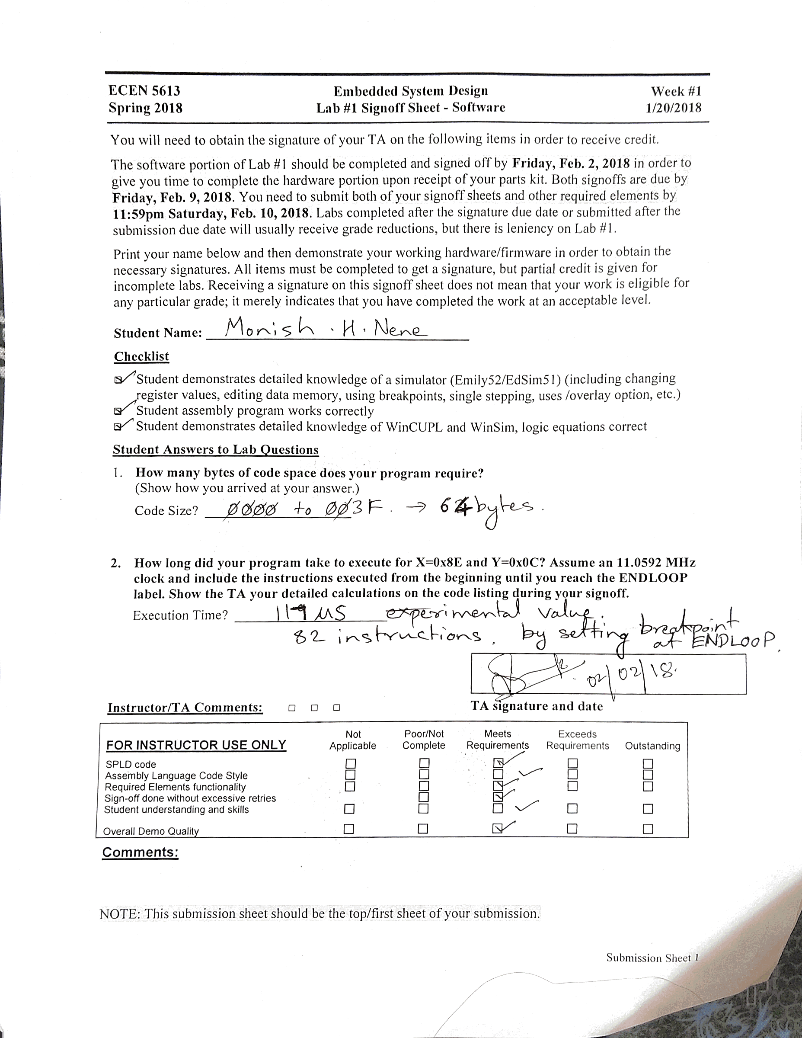

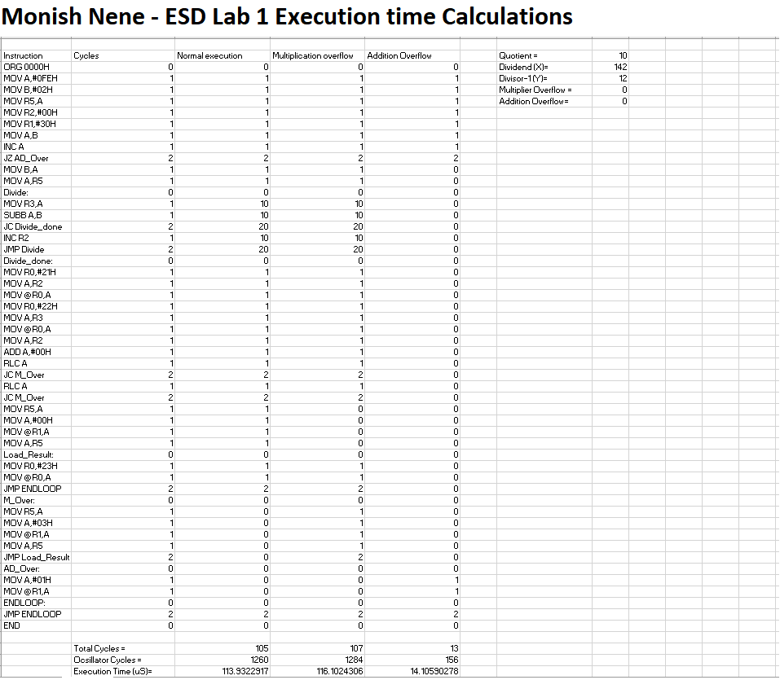

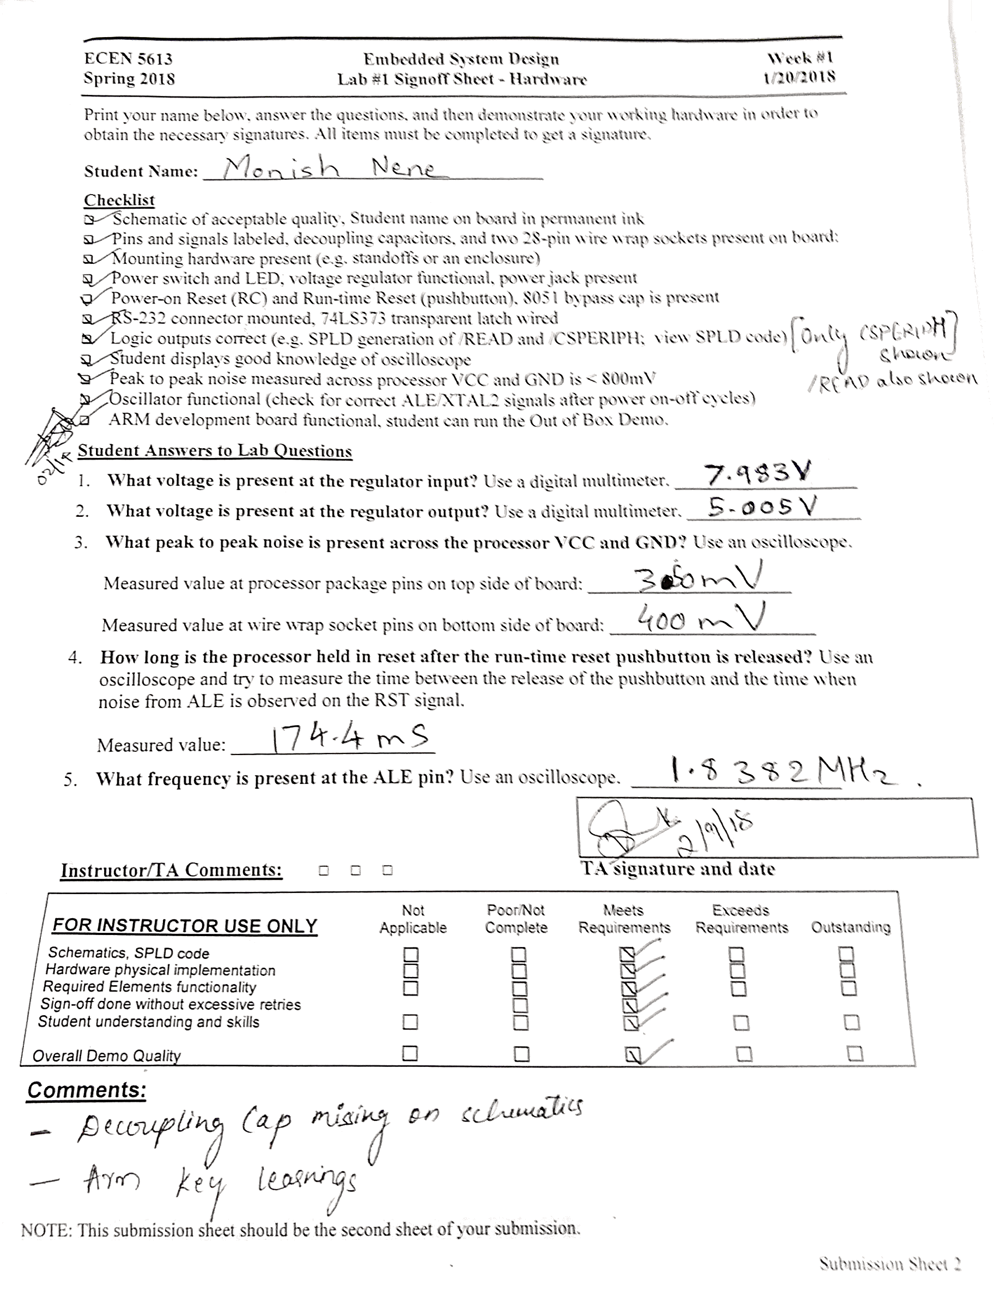

Schematic

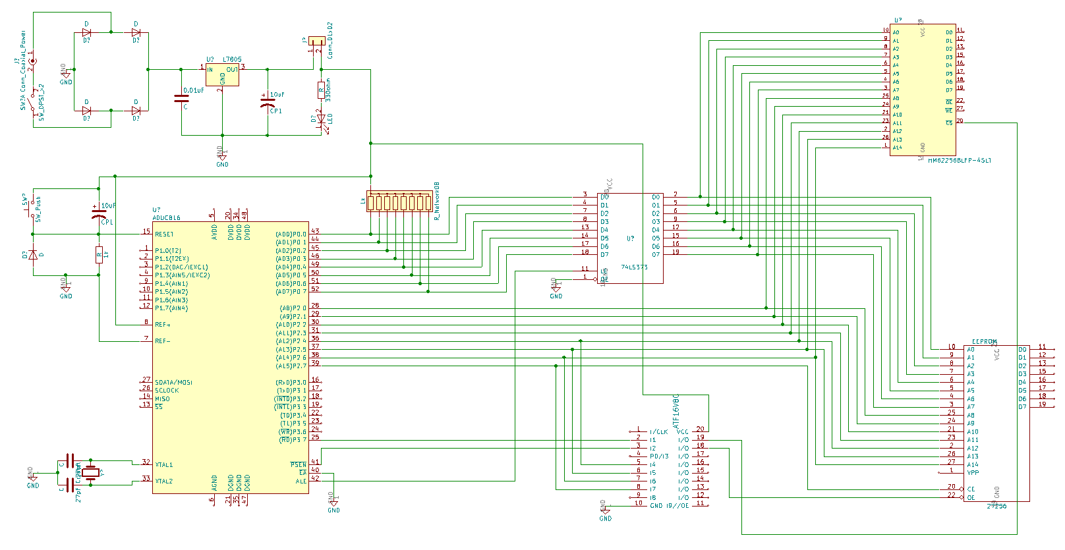

ALE

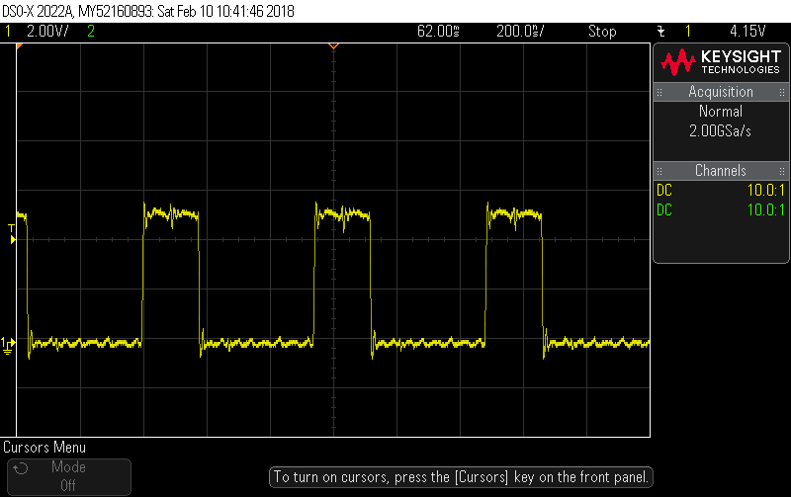

ALE signal on RESET

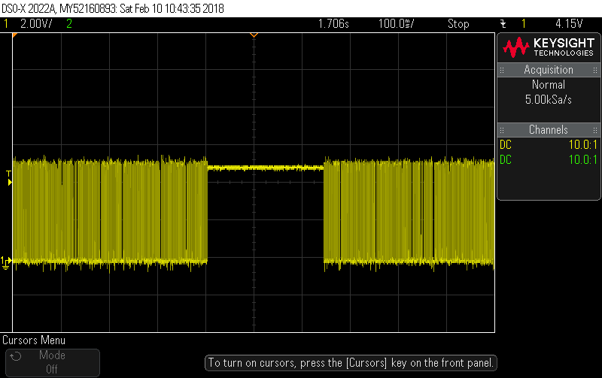

READ Output from ATF16V8C

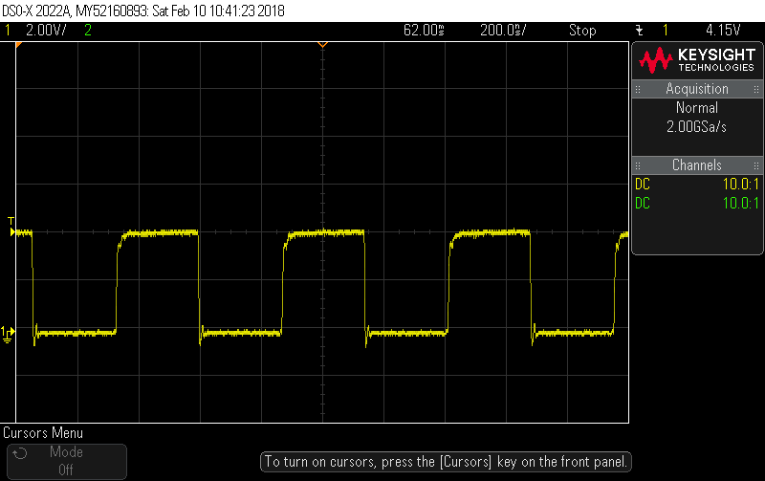

CSPERIH Output from ATF16V8C

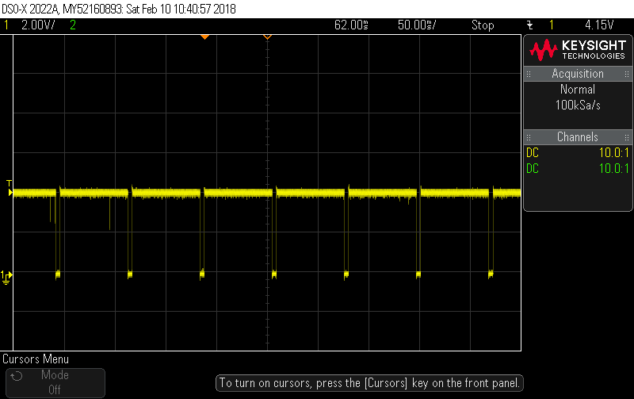

TI demo – Blinking LED example code

LED OFF

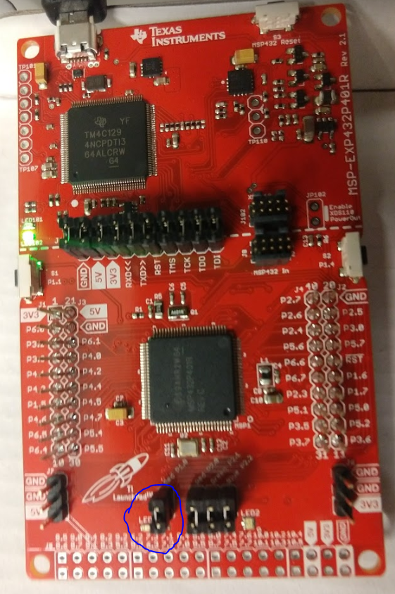

LED ON

